Esther T. Thyssen

7 Williams Street

Salem, MA 01970

[esther.thyssen@gmail.com](mailto:esther.thyssen@gmail.com)

**Smith, David Roland (1906-1965) Word Count: 524**

David Smith was the pre-eminent sculptor of the New York School. Best known for his iron and steel constructions, Smith created cohesive sets of sculptures, each organised around a particular system of forms, metaphors, and methods. Smith studied painting in New York with Czech modernist Jan Matulka (1890-1972), and later worked for the WPA sculpture division (1939). He learned most about the European avant-garde from the émigré intellectual John Graham (1886-1961), originally a friend of Smith's wife Dorothy Dehner (American sculptor 1901-1994). Through Graham's introductions the couple met avant-garde artists in Europe during travels there in 1935-36. Smith considered the constructions of Julio Gonzalez and Pablo Picasso the forebears of his oeuvre. Smith sculpted found metal with the oxyacetylene torch and welded the cut shapes together. Planar parts are joined at angles to entrap space, or layered thinly to slice through space rather than to displace it. From the mid-fifties until his death in a car accident in 1965, Smith's output was prolific and monumental, his process driven by his wartime experience as a machinist and metals fabricator. Smith defined a new status for American sculpture with origins in European modernism and American industry and production, and by the critical validation his oeuvre attained.

Smith was born in Dacatur, Indiana. His first series, fifteen cast reliefs entitled *Medals of Dishonor* (1937-40) satirise World War II atrocities, and rely on Surrealist influence amplified by Dehner. Smith's contemporaneous constructive sculpture is small in scale and exploits cubist subjects: heads, landscapes and interiors pieced together from obsolete tools, offcuts, and scrap metal. By 1943 Clement Greenberg acclaims Smith's work for advancing modernism in America. As recipient of the Guggenheim Fellowship (1951-53) Smith could afford new materials and to work larger. New monumental constructions like *Australia* (1951) emerged as he twisted and welded steel strips to trace his gesture in space. This concern with line is carried forward in the *Agricola* series begun in the same year, but developed from obsolete farm equipment. The *Tanktotem* series (1952-60) on the other hand uses boiler parts ordered new from an industrial supply catalogue. Smith’s work was at the Venice Biennale in 1954 and 1958, and in 1962 he made sculpture for the Spoleto Festival by invitation. Smith welded twenty-seven monumental assemblages from tools and manufacturing equipment at the abandoned factory site in Voltri, Italy, in just one month to great acclaim. Afterwards at his Bolton Landing studio, Smith carried on with the *Cubi* series and made additional constructions with material retrieved from Italy. Smith's spatial, material, and process innovations impacted the sculpture of his generation, influencing artists such as Richard Stankiewicz, Mark di Suvero, Richard Serra and Sir Anthony Caro. Smith legitimated the direct-metal process, the use of industrial materials and fabricated elements, as well as overwhelming scale in post-war sculpture. His prestige secured the modernist plinth from which the next generation moved into Minimalism.

**References and further reading**

Krauss, R. (1971) Terminal Iron Works: The Sculpture of David Smith, Cambridge, MA: The MIT Press.

Merkert, J. (ed.) (1986) David Smith: Sculpture and Drawings with Selected Writings by David Smith, Munich: Prestel-Verlag.

Gimenez, Carmen. (ed.) (2006) David Smith: A Centennial, New York: Guggenheim Museum.

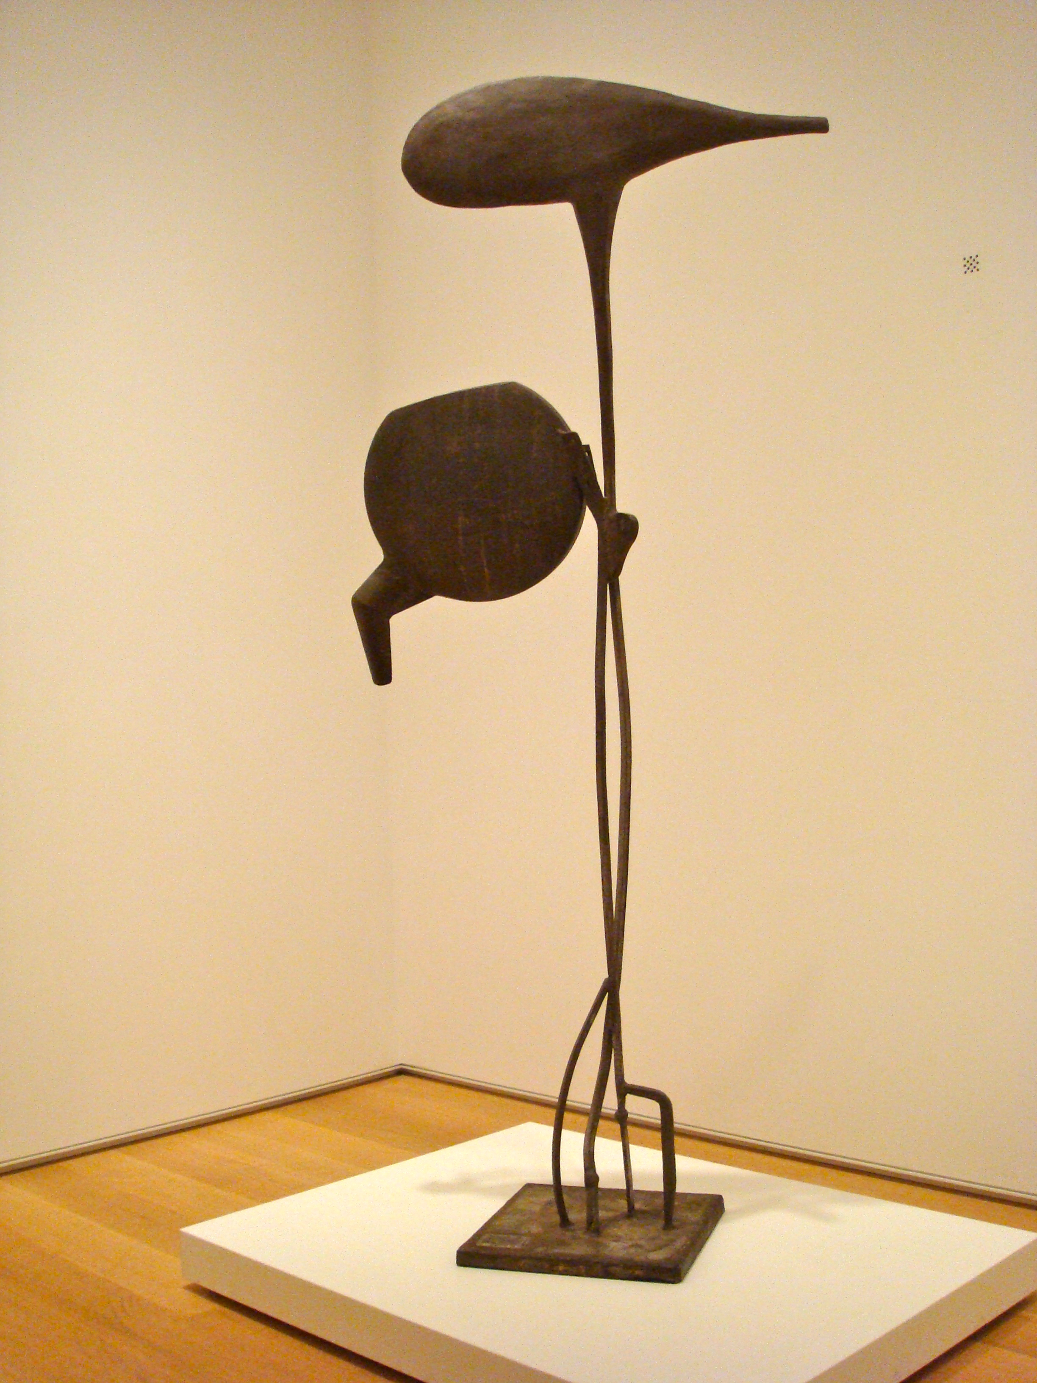

Tanktotem I, 1952

Steel  
228 x 99 x 42 cm (89 3/4 x 39 x 16 1/2 in.)  
  
Gift of Jay Steinberg and Muriel Kallis Steinberg in memory of her father, Maurice Kallis, 1953.193

Art © Estate of David Smith / Licensed by VAGA, New York, NY

http://www.artic.edu/aic/collections/artwork/79379